Sprint 1 vs Sprint 2 Change Summary
Note: “Removed / no longer repeated / scope exclusions” distinguishes confirmed exclusions from Sprint 1 functions that are simply not repeated in this incremental Sprint 2 document.
Comparison item | Added or modified | Removed, not repeated, or out of scope
Entities and relationships | Added CheckIn, LocationPoint, Event, EventInterest, PrivacySetting, and FriendVisibility. Existing user data is represented by User_EXTERNAL, with new relationships for Check-ins, optional locations, event marks, privacy defaults, and friend access decisions. | Sprint 1 entities are not repeated in this incremental ERD and are not confirmed as deleted. No independent Mood, full Friendship, Booking, Payment, Attendance, or Weather entity is introduced.

Phase 2 - Mini ERD
COMP3851A Sprint 2 | Group D Deliverable
Purpose: provide a small, traceable Sprint 2 data model that supports Check-in, approximate location, Friends Visibility, Events, EventInterest, and approved privacy boundaries.
Source-status decisions applied: no independent Mood entity; no Friendship entity; no implementation-level deletion fields; LocationPoint stores only reduced-precision location labels; CheckIn.visibility and EventInterest.visibility are the content-level visibility sources of truth.

1. Mini ERD Visual Diagram and ERD source
The visual ERD below represents the Sprint 2 mini data model. It is intentionally small and prototype-level.
ERD source: the diagram and tables are generated from the approved Sprint 2 mini ERD source. The visual diagram is for review; the Entity Summary, PK / FK / Unique Constraints, and Relationship tables are the authoritative data-model content.
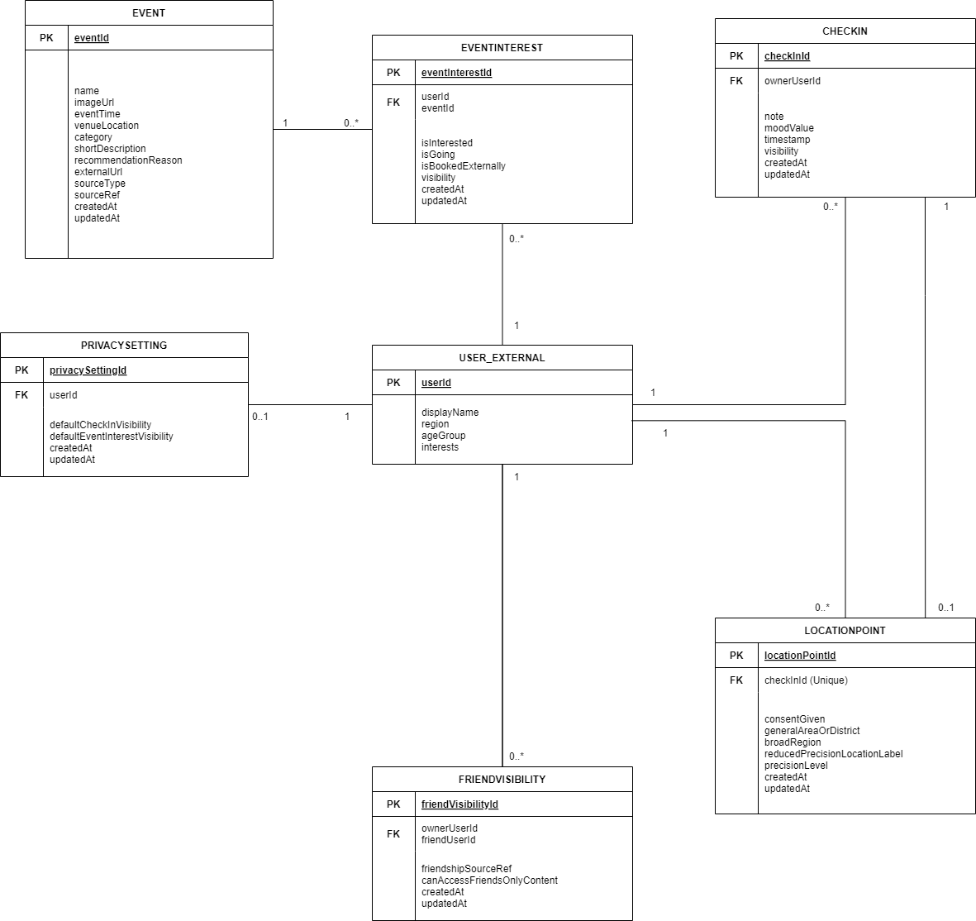
Figure 1. Sprint 2 Mini ERD visual diagram
Reading note: the visual diagram is for quick review. The entity summary and relationship tables below are the authoritative field and rule list. EventInterest is unique per User and Event. isInterested, isGoing, and isBookedExternally are manual marks and may coexist.

2. Entity Summary Table
Entity | Purpose | PK | Core Fields | Source Status | Notes
User_EXTERNAL | External user reference used by Sprint 2 flows. | userId | displayName; region; ageGroup; interests | Confirmed by frozen Sprint 2 / external reference | Not a full user-management model. Supports owner/viewer references and recommendation attributes when available.
PrivacySetting | Stores the user's default privacy preference. | privacySettingId | PrivacySetting.userId: FK Unique; defaultCheckInVisibility=Private; defaultEventInterestVisibility=Private; createdAt; updatedAt | Approved derived design | User-level default only. It cannot create new content as Friends-only; Friends-only requires explicit user change on CheckIn.visibility or EventInterest.visibility.
CheckIn | Stores a saved Check-in created by a user. | checkInId | ownerUserId; note; moodValue; timestamp; visibility; createdAt; updatedAt | Confirmed by frozen Sprint 2 + approved design | note or moodValue must be present. timestamp is automatic. CheckIn.visibility initial value is Private and remains the content-level source of truth.
LocationPoint | Stores optional approximate location attached to one Check-in. | locationPointId | checkInId FK Unique; consentGiven; generalAreaOrDistrict; broadRegion; reducedPrecisionLocationLabel; createdAt; updatedAt | Approved derived design | Optional and consent-based. FK direction is LocationPoint.checkInId only. Stores reduced-precision location label only; no high-detail location data.
Event | Stores event information from an approved external source, API, or mock API. | eventId | name; imageUrl; eventTime; venueLocation; category; shortDescription; recommendationReasonDisplay; externalUrl; sourceType; sourceRef; createdAt; updatedAt | Confirmed by frozen Sprint 2; recommendationReasonDisplay: Derived design - needs team confirmation | Supports Event Suggestions, Event Details, recommendation reasons, and external redirect only. The reason is treated as a display output, not a confirmed permanent Event attribute.
EventInterest | Stores one user's manual event marks for one event. | eventInterestId | userId FK; eventId FK; EventInterest(userId, eventId): Composite Unique(userId,eventId); isInterested; isGoing; isBookedExternally; visibility; createdAt; updatedAt | Approved derived design | One record per User and Event through Composite Unique(userId,eventId). Boolean marks can coexist. EventInterest.visibility initial value is Private and remains the source of truth for event activity sharing.
FriendVisibility | Checks whether an existing friend can access owner-permitted Friends-only content. | friendVisibilityId | ownerUserId; friendUserId; FriendVisibility(ownerUserId, friendUserId): Composite Unique if persisted; friendshipSourceRef; canAccessFriendsOnlyContent; createdAt; updatedAt | Derived design - Needs team confirmation for persistence | Business-rule representation / prototype access representation. It does not store content visibility and relies on assumed external friendship relationships.

3. Relationship and Cardinality Table
From | To | Cardinality | Meaning | Optionality / Rule
User_EXTERNAL | PrivacySetting | 1 : 0..1 | A user may have one default privacy preference record. | Optional until the user default is created.
User_EXTERNAL | CheckIn | 1 : 0..* | A user owns many Check-ins; each CheckIn belongs to one owner. | Mandatory owner reference.
CheckIn | LocationPoint | 1 : 0..1 | One CheckIn has zero or one LocationPoint. One LocationPoint belongs to exactly one CheckIn. | FK is LocationPoint.checkInId with Unique constraint; CheckIn has no locationPointId FK.
User_EXTERNAL | EventInterest | 1 : 0..* | A user may create many event mark records. | Unique User + Event combination.
Event | EventInterest | 1 : 0..* | An event can receive many user mark records. | No booking/payment/attendance record is created.
User_EXTERNAL as owner | FriendVisibility | 1 : 0..* | An owner may have many friend access checks. | External friendship relationship is assumed.
User_EXTERNAL as friend | FriendVisibility | 1 : 0..* | A friend may appear in many access checks. | No Friendship entity or friend-management workflow.
CheckIn.visibility | FriendVisibility | Business rule | Friends can see Check-in content only when CheckIn.visibility is Friends-only and FriendVisibility allows access. | CheckIn.visibility remains source of truth.
EventInterest.visibility | FriendVisibility | Business rule | Friends can see event activity only when EventInterest.visibility is Friends-only and FriendVisibility allows access. | EventInterest.visibility remains source of truth.

4. PK / FK / Unique Constraints
Entity | Field / Combination | Constraint | Rule
PrivacySetting | privacySettingId | PK | One PrivacySetting record identifier.
PrivacySetting | PrivacySetting.userId | FK + Unique | One external user has at most one PrivacySetting record.
CheckIn | checkInId | PK | One saved Check-in identifier.
CheckIn | ownerUserId | FK | References the external owner user.
LocationPoint | locationPointId | PK | One optional LocationPoint identifier.
LocationPoint | LocationPoint.checkInId | FK + Unique | Only FK direction between CheckIn and LocationPoint. One CheckIn has zero or one LocationPoint.
Event | eventId | PK | One event identifier from the approved event source or mock source.
EventInterest | eventInterestId | PK | One manual event-mark record identifier.
EventInterest | userId; eventId | FK + Composite Unique(userId,eventId) | One User and one Event can have only one EventInterest record.
FriendVisibility | friendVisibilityId | PK if persisted | Prototype access-check identifier only if FriendVisibility is persisted.
FriendVisibility | FriendVisibility(ownerUserId, friendUserId) | Composite Unique if persisted | FriendVisibility persistence is Derived design - Needs team confirmation.
FriendVisibility | friendshipSourceRef | External reference | Existing friendship relationships are assumed; no Friend-management workflow is added.

5. Key Assumptions
- Existing friendship relationships are supplied by an external or already existing system.
- User_EXTERNAL is an external reference, not a new full User management module.
- Mood is stored as CheckIn.moodValue and is not an independent Mood entity.
- LocationPoint stores only generalAreaOrDistrict, broadRegion, or a reduced-precision location label after explicit consent.
- Event data is supplied by an approved external source, API, or mock API.
- EventInterest uses one record per User and Event with three manual boolean marks.

6. Scope exclusions / Confirmed Scope Boundaries
- No Friendship, FriendRequest, FriendRecommendation, friend search, friend matching, add/delete/block/report friend workflow.
- No selected-person visibility, Trusted Friend visibility, Public visibility, or group visibility.
- No high-detail location data, live location, continuous tracking, background tracking, or independent location-sharing module.
- No implementation-level deletion fields, recycle bin, restore, database cascade, or deletion-synchronisation mechanism in the Mini ERD.
- No in-app booking, payment, ticketing, refund, cancellation, QR check-in, attendance record, booking verification, or attendance verification.
- No ranking scores, similarity percentages, AI confidence scores, internal ranking details, or learning-system entity.
- No medical profile, diagnosis, treatment, psychological classification, sensitive profile, or professional-advice entity.

7. Derived Design Decisions
- PrivacySetting is user-level default preference only.
- CheckIn.visibility is the content-level source of truth for Check-in visibility.
- EventInterest.visibility is the content-level source of truth for event activity visibility.
- FriendVisibility checks external friendship access and does not duplicate content visibility.
- LocationPoint is optional and stores only generalAreaOrDistrict, broadRegion, or reduced-precision location label.
- EventInterest uses isInterested, isGoing, and isBookedExternally booleans; combinations are allowed and remain manual marks.
- createdAt and updatedAt are simple record timestamps only; they do not create lifecycle, audit-log, restore, or deletion workflows.

8. Implementation Notes
- moodValue labels may be refined by the prototype team, but must remain non-diagnostic.
- New CheckIn and EventInterest records start as Private. PrivacySetting cannot bypass that initial Private state; Friends-only requires explicit user change on the content item.
- External user and friendship reference field names may follow the existing system or mock data source.
- Event source field names may follow the approved API or mock API.
- Any raw location input must be reduced to generalAreaOrDistrict, broadRegion, or a reduced-precision location label before storage; high-detail or address-level location data must not be stored in this Mini ERD.
- Final data types, field lengths, and UI display labels may be refined during implementation without changing Sprint 2 scope.

Updated Review / Phase Review
Review Item | Result
Deliverable type | Actual Mini ERD with visual diagram, entity summary, relationships, assumptions, boundaries, decisions, and implementation notes.
Group D task alignment | Connects User_EXTERNAL, CheckIn, moodValue, LocationPoint, Event, EventInterest, PrivacySetting, and FriendVisibility while keeping the model mini.
Frozen Sprint 2 alignment | Supports Check-in, optional approximate location, Calendar/Map/Timeline/Heatmap, Friends Visibility, Event marks, External Booking redirect, and AI recommendation inputs without adding excluded modules.
Source-status decisions applied | Approved derived design is kept only where supported by user decisions; FriendVisibility persistence and recommendationReasonDisplay storage are marked as derived items needing team confirmation.
Traceability readiness | Entities and fields can support Phase 1 AC and later Phase 3 UAT while staying consistent with Phase 4-6 data specifications.

